**Capital Requirements**

Basel Regulatory Capital

On Basel Regulatory Capital there are two principal components required to obtain the capital requirements: one market component and one risk component.

Market Regulatory Capital

Based on the Basel 2.5 document, the following formula needs to be used to calculate our market risk regulatory capital:

$$K=\max\left(VaR_{10d 99\%};mc VaR_{avr 10d 99\%}\right)+max⁡(SVaR_{10d 99\%};mc SVaR_{avr 10d 99\%})$$

Where:

K : is the regulatory capital

VaR: Value at Risk with 10-day horizon and 99% certainty

mc : regulatory constant, that the minimum number is a 3, and the maximum is 4 (depending to the regulatory authority). We are assuming a 3.1 (as a AA company with no major changes to be done in the structur e of our company).

SVaR: Stressed Value at Risk for a time horizon predetermined, over 2 years. In our case, we are considering the time frame between March 2007 and December 2009, where the VaR calculation is higher. In our case it is from March 2007 to March 2009.

VaRavr : Consider the average of the last 60 days of the VaR calculation.

SVaRavr : Consider the average of the last 60 days of the Stressed VaR calculation.

To make this calculation, we decided to calculate it in a conservative way, so we are taking the historic VaR method (that is higher than the Monte Carlo simulation).

In addition, we are not considering the 60 average, although it is a requirement.

The capital regulatory is the following:

$$K= 98.6 MCAD$$

Credit Regulatory Capital

Based on the Basel 2.5 document, we need to compute the Incremental Risk Charge (IRC). It is a complement for the VaR framework that includes the effect of the credit rating migration; downgrades are also considered in credit risk modeling. We are considering the same transition matrix for corporate bonds and CDS. We are considering S&P 2015 matrix for one year.

CreditMetrics methodology as well as Gaussian copulas is used to model the rating transitions. The one-year 99.9% VaR is calculated using 10000 MC simulations:

$$IRC K=⁡VaR_{1Y 99.9\%}$$

$$VaR_{1Y 99.9\%}=50.6 MCAD$$

In this example, we are not considering the CDS’s for time issues. But, if considered, the capital requirement needs to increase considerably, to around 10MCAD additional to the 51MCAD we already have.

Rest of capital requirements

Economic Capital:

The Economic Capital is the Capital designated to cover unexpected Market losses. The Economic Capital provides a forward looking estimate of the difference in the maximum potential loss and our expected loss:

$$K_{economic}=VaR_{10d99\%}-Expected Loss$$

$$13.46= 14.4-0.94$$

Counterparty Credit Risk (CCR):

CCR is the risk associated with the counterparty defaulting. The default risk component is calculated using the Standard or IRB approach according Basel framework. Credit Value Adjustment (CVA) capital is to mitigate the MTM losses on the expected CCR for derivatives.

Standardized Approach:

The capital allocation is based on the following formula proposed in Basel 1, where the weights and credit equivalent add-on factors are:

$$K=0.08 (Σ_{j}RWA_{j})$$

Where the ratings on the credits pay an important part on the weights to affect the debt:

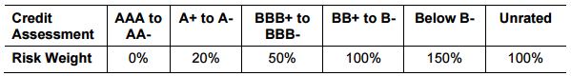

And the RWA categories are according to the following[1]:

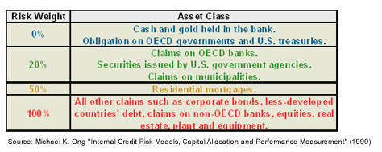

, representing 3.1% of the Total CDS Exposure.

Standardized CVA Capital:

In the standardized approach, the portfolio CVA capital charge is calculated using the following formula:

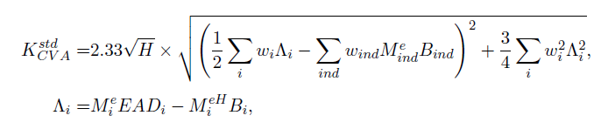

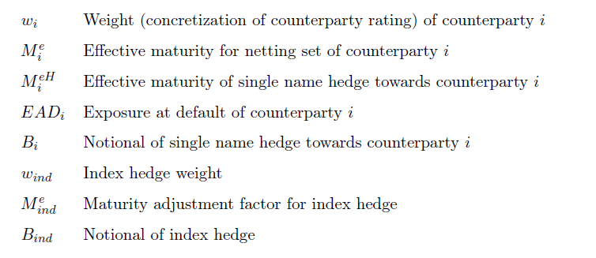

The ratings involved giving a percentage of the weights (represented by Λi) are the following:

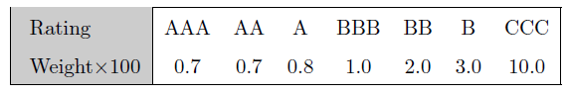

The capital we obtain for the CVA is the following:

$K=223 kCAD$, representing 2.6% of the Total CDS Exposure.

1. http://www.investopedia.com/articles/07/baselcapitalaccord.asp